UoN Men’s volleyball team dominated a game against opponents with no substitute.

UoN Men’s Volleyball team has gained their first win in the new season by beating University of Derby in [ 3-0 /25-11 /25-15 /25-16 ].

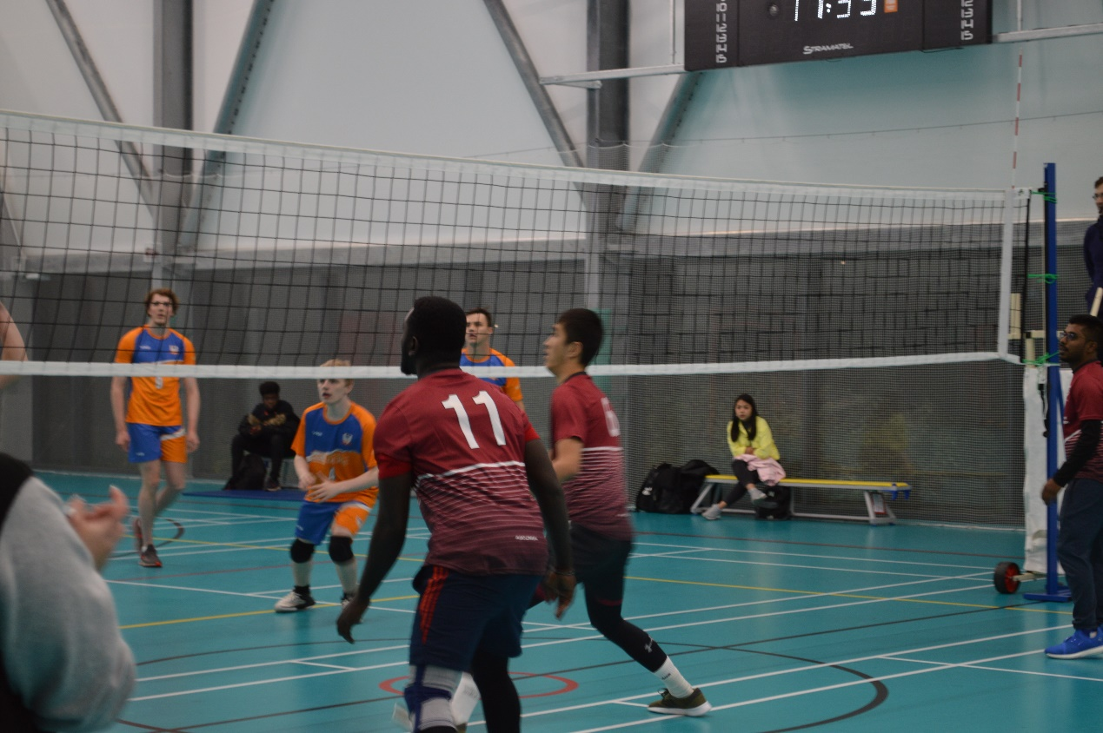
[Highly focused players during the game.]

After a “not so good ” season last year, UoN Men’s Volleyball team hope to have a fresh start in the new season. However, the first game turned out to be a disappointing result. [] In the game against University of Derby, they clear all their depression with a superb win.

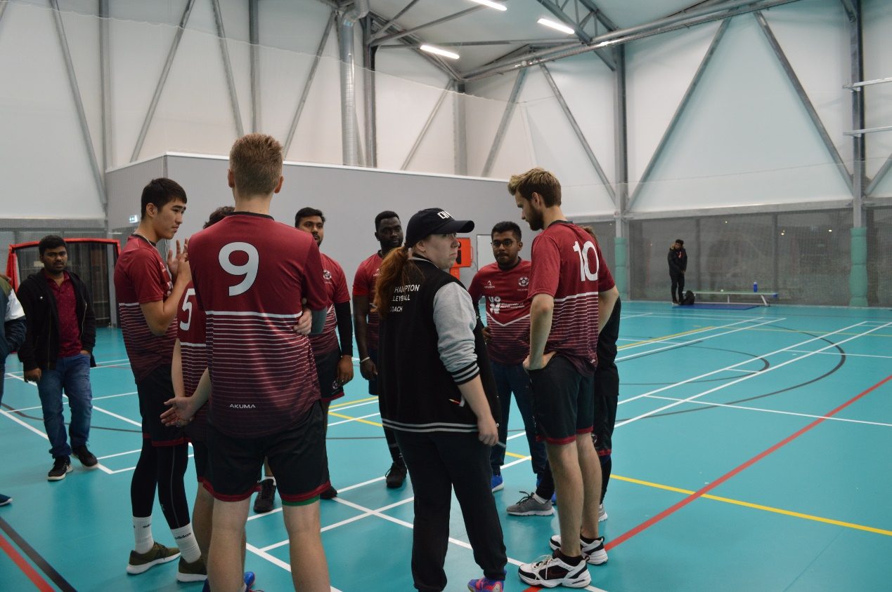
[The coach analyzing situation during timeouts]

UoN has some strong players such as No.11 Samuel, who scored most of the points in the first and third set, and No.7 Mo, who is a all-rounded player with firm performance throughout the game. “We shall be careful at first, and be tough as we warm up. Just enjoy it. ” said the UoN’s coach.

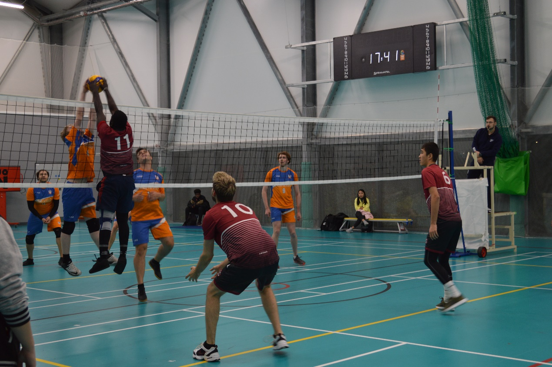
[Sameul’s tough block]

On the other hand, University of Derby tends to be a bit amateur. They didn’t have substitutes, coaches, they didn’t even have a Libero. The strongest player of them all is No. 4 Kai.Patrick, who is only 5’’8 tall. With a weak attacking performance and even weaker defending performance, they didn’t really challenge UoN that much.

[UoD teammates’ heatedly discussion during timeouts. ]

“Our performance can definitely be better, but we’re satisfied with it considering we’re basically amateur, It’s been a wonderful little trip. I hope we could be better next time we’re here.” Said the captain pf University of Derby.

