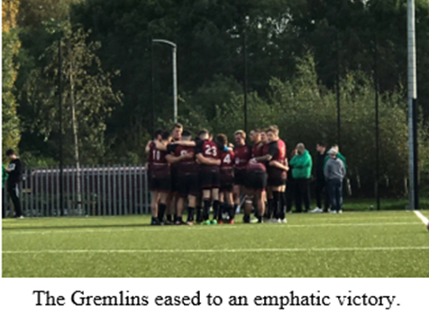
University of Northampton 1s 70-4 Nottingham Trent 2s
University of Northampton 1s dominated Nottingham Trent 2s on Wednesday, winning by a comfortable 70-4 and extending their impressive start to their BUCS Midlands 2A campaign.

In the first play of the match, Northampton made a breakthrough after Isah Lawal-Saulawa, who impressed throughout, ran with the ball and set up Christakis Constantinou, who scored under the posts, the try being converted by Ollie Cooper.

Shortly after, the pacey loose forward Lawal-Saulawa was played through by a kick, before he side-stepped and scored unimpeded near the posts, with Cooper again converting.

Lawal-Saulawa and Constantinou later linked up as they did with the Gremlins’ first try, but this time Cooper’s conversion was missed from a tight angle.

A few minutes later, Ryan Armstrong ran down the right wing and scored in the corner, however a Cooper conversion from the touch line was missed.

From a Northampton penalty soon after, Kyle Jones ran straight through the Trent line, scoring a try that was far too easy, with Nottingham players standing off him - Cooper converted from under the posts.

Cooper himself shifted to the left moments later, setting up Brad Dennison for a simple try, from which Ryan Parsons impressively scored his conversion from a wide angle.

Just before half time, Serafim Parente ran from the left around the Trent back line and scored under the posts - George Hopson converted, and the Gremlins went in at the break leading 38-0.

Nottingham started the second half brightly, as their half time substitute runs straight through the Northampton line and scored, however the resulting conversion was poor.

The Gremlins took back control relatively quickly, as Ryan Armstrong scored a try to the left of the posts, before Cooper hit the post with his conversion.

In the next passage of play, Armstrong again got through after some quick passes, and this time Ryan Parsons converted.

Minutes later, Cooper beat two challenges and scored, having recovered after being hauled to the ground by a Trent player, before converting his try.

Serafim Parente scored in the corner, but Ryan Parsons followed up with a weak conversion soon after.

Parente again ran straight through in the next passage of play, scoring another try to finish another impressive passing move from Northampton - the conversion was scored by Ryan Parsons.

In the last play of the match, Paulo Owens scored a deserved try, powering through Nottingham’s players and not for the first time in the game, before Ryan Armstrong converted, meaning that the Gremlins ended the match as 70-4 winners.

Northampton go into their next match away to University of Leicester 1s full of confidence having picked up two good victories so far this season, with each member of the team putting in a good quality performance on Wednesday.

